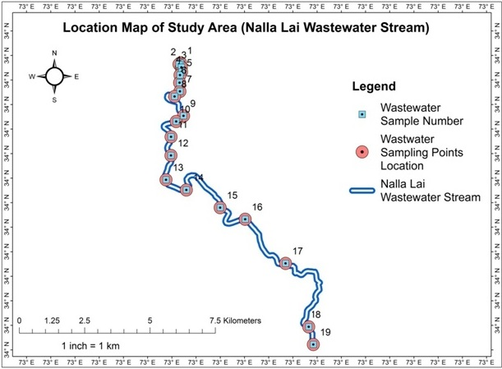

**Figure 1 |** ArcGIS Map of Wastewater Sampling Points Location of Nalla Lai Stream (Study Area)

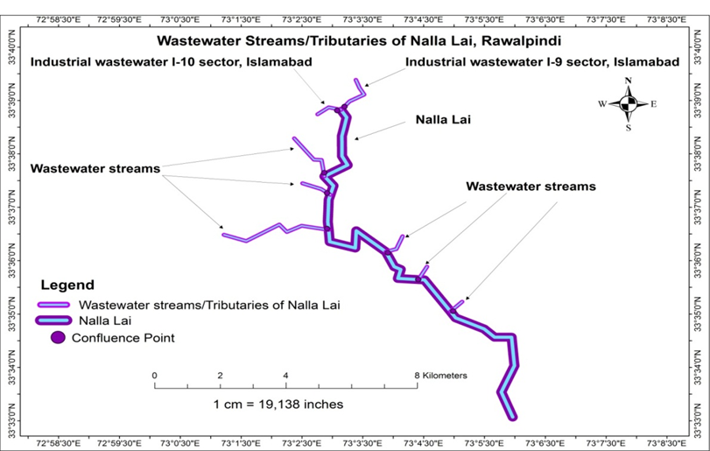

**Figure 2|** ArcGIS Map of Wastewater Streams/Tributaries of Nalla Lai in Rawalpindi

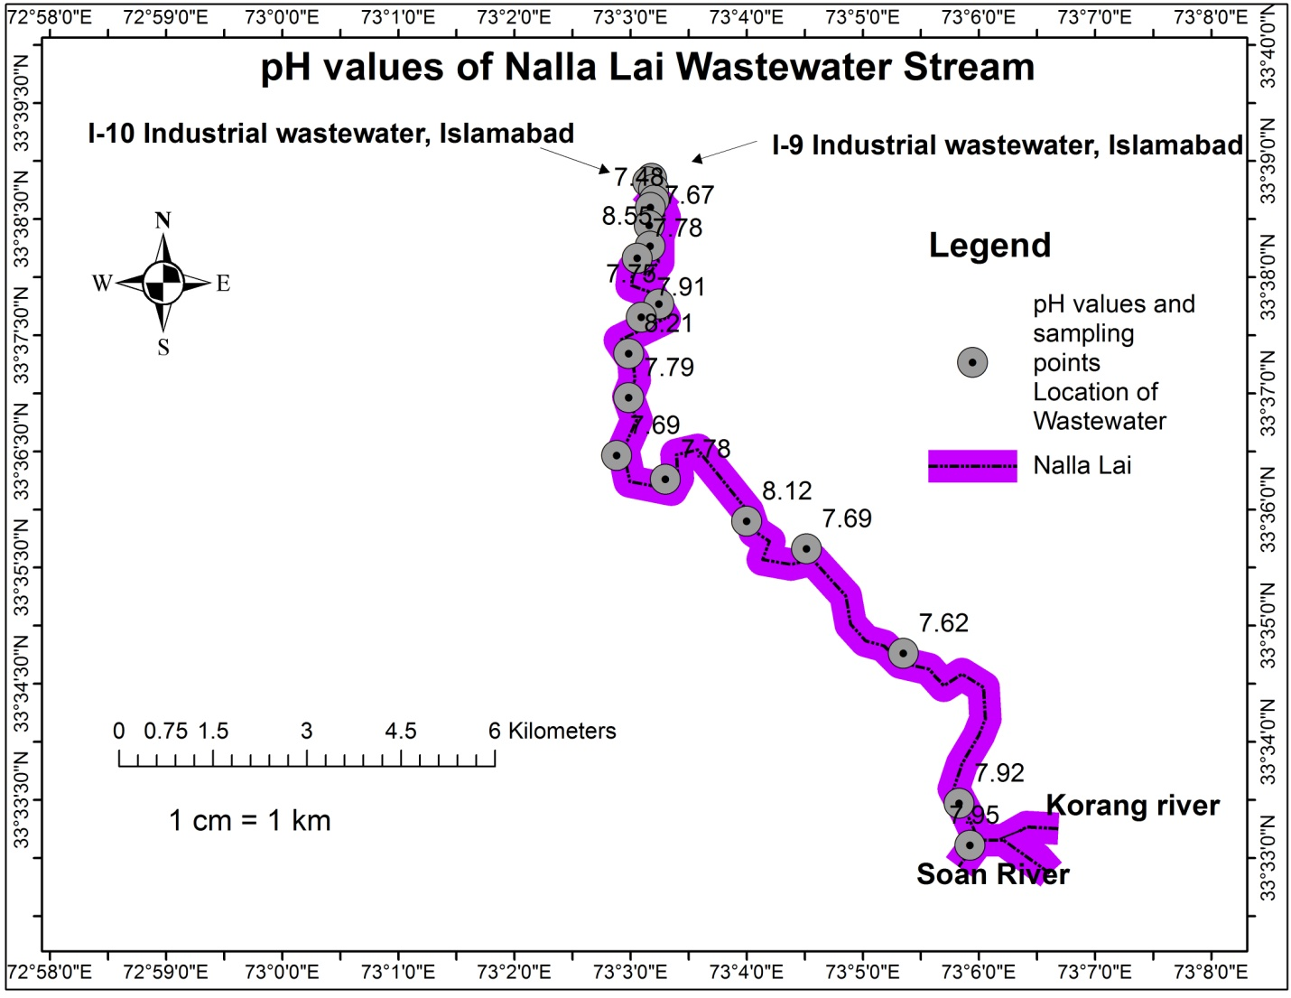

**Figure 3 | pH** values of wastewater samples along the Nalla Lai stream

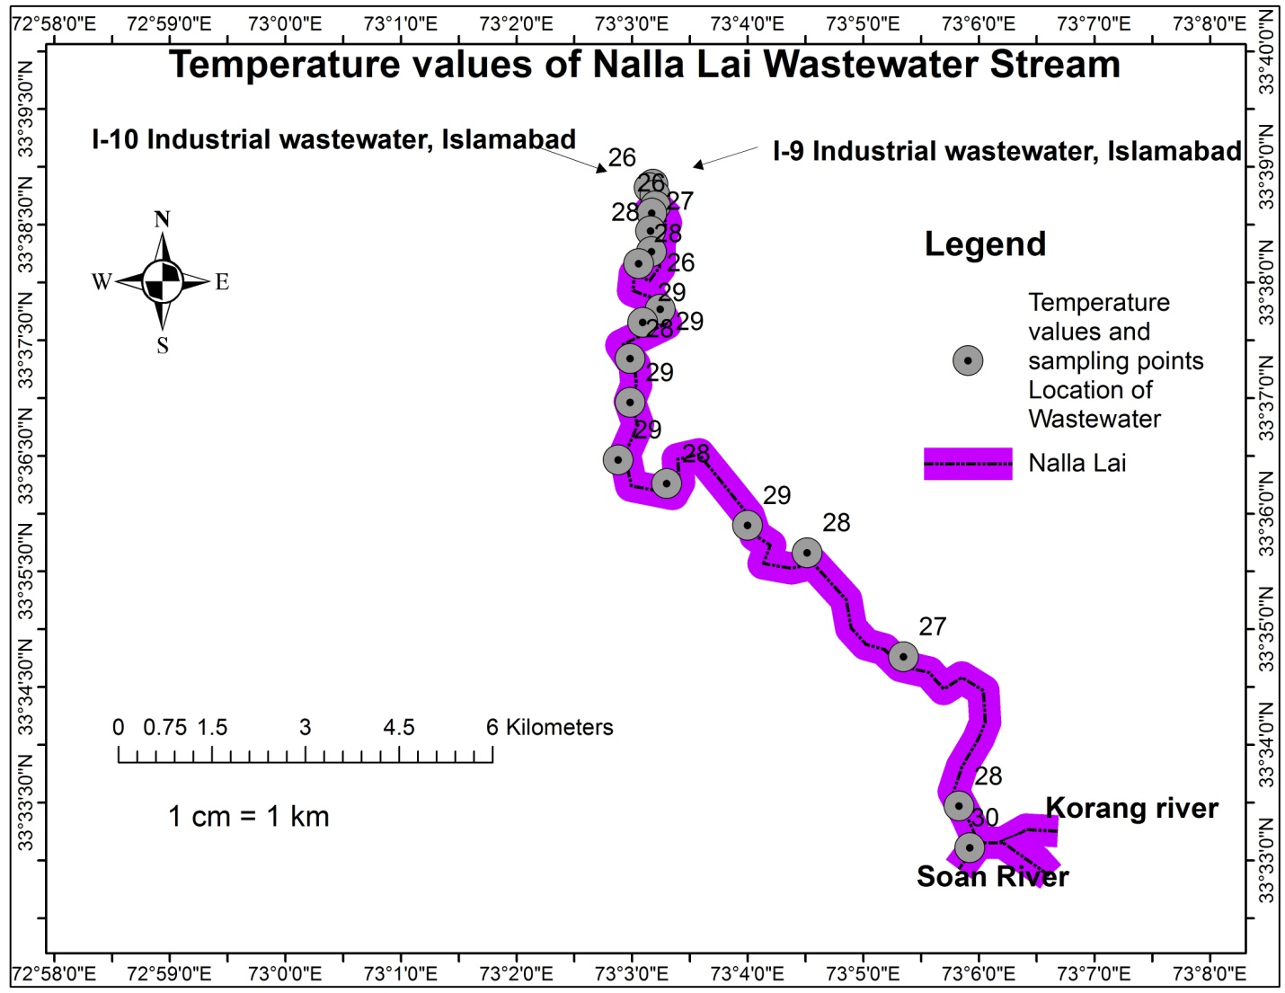

**Figure 4|** **Temperature** values of wastewater samples along the Nalla Lai stream

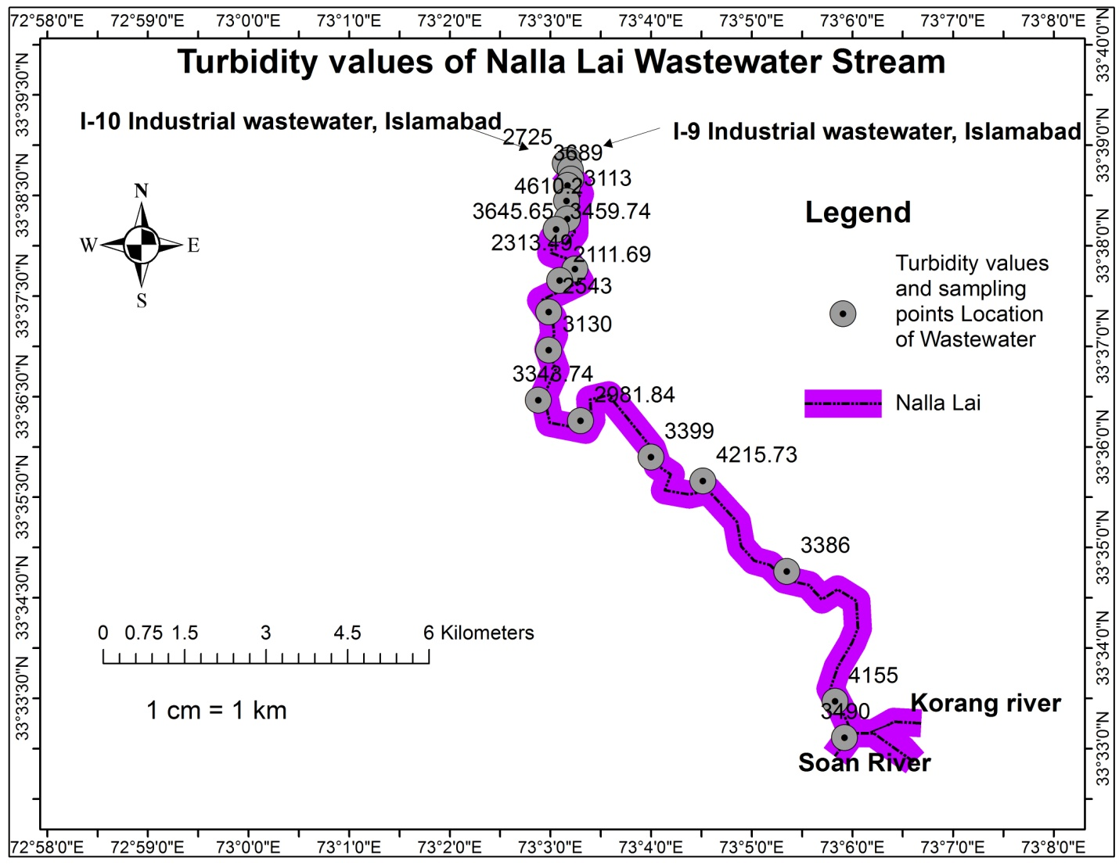

**Figure 5|** **Turbidity** values of wastewater along the Nalla Lai stream

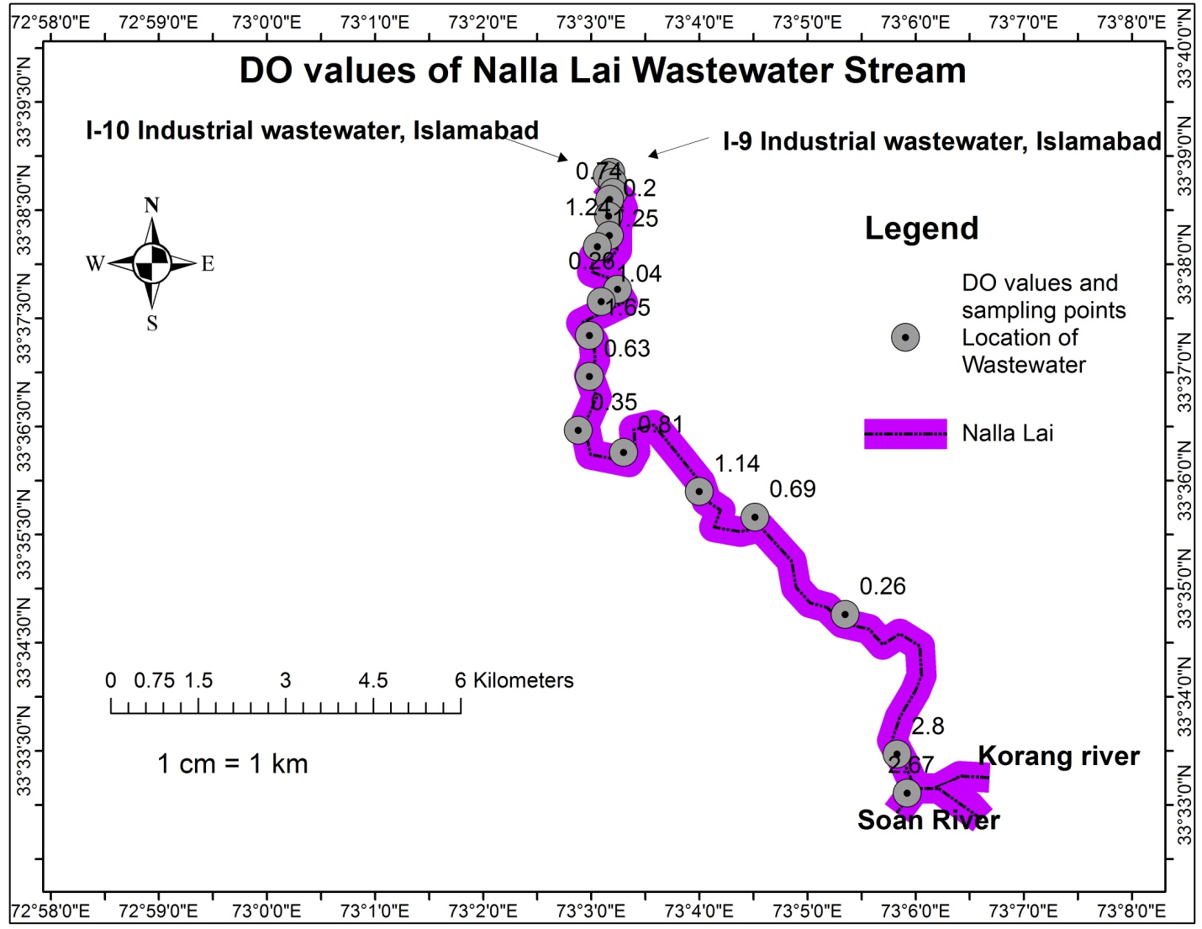

**Figure 6| Dissolved Oxygen** values of wastewater along the Nalla Lai stream

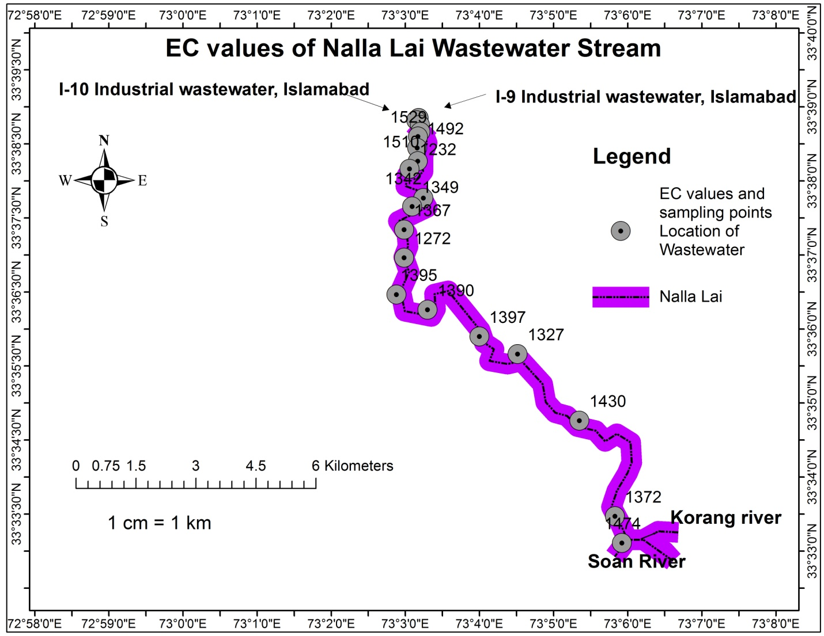

**Figure 7|** **Electric Conductivity** values of wastewater along the Nalla Lai stream

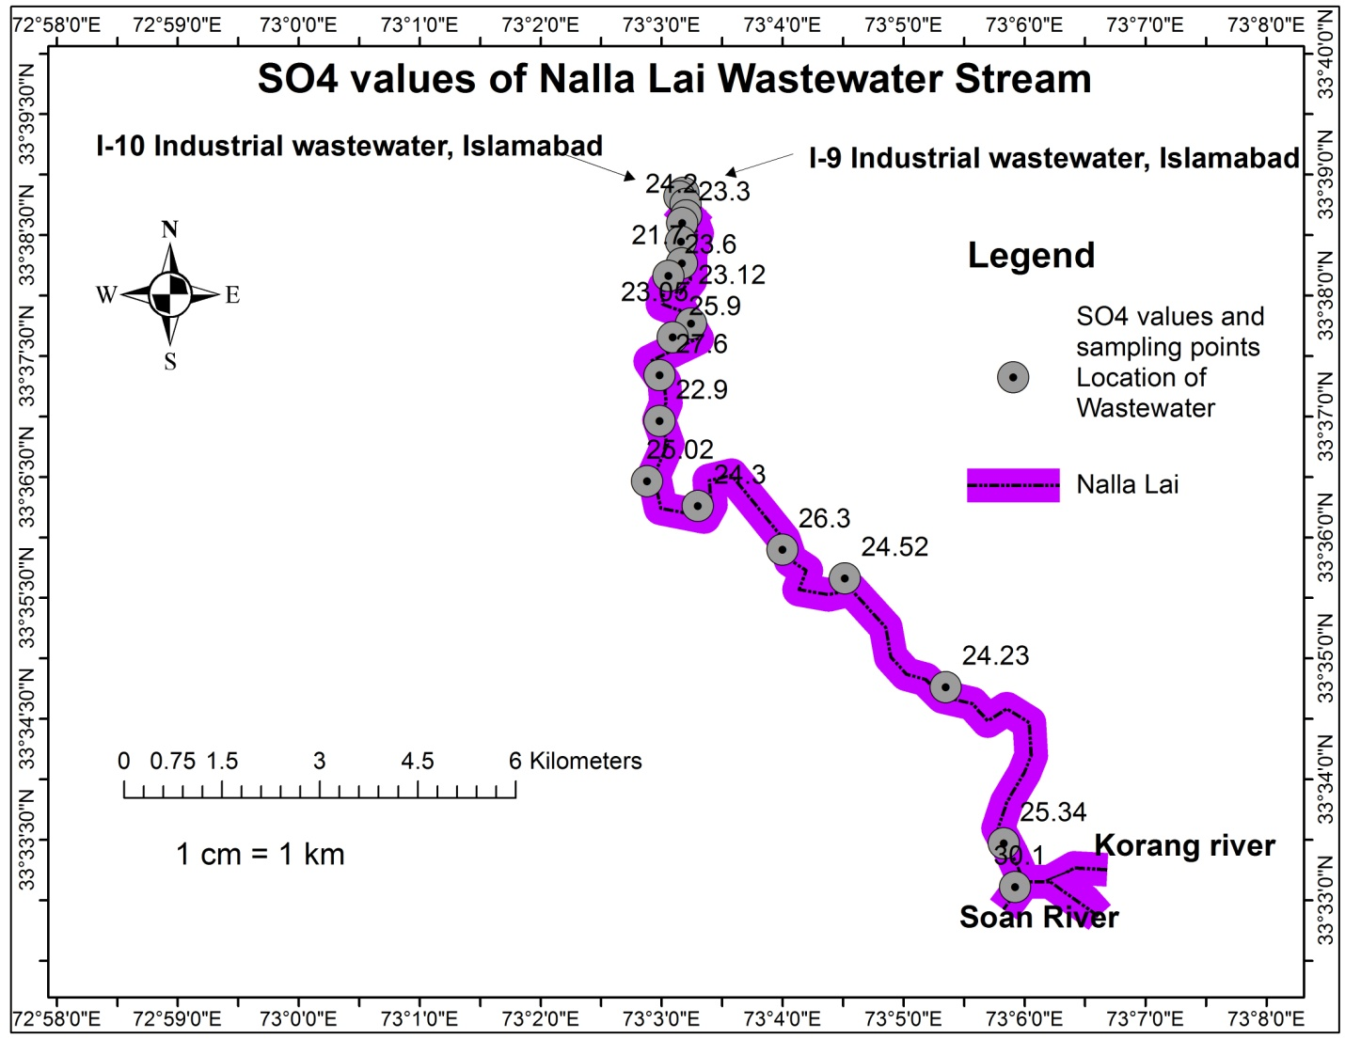

**Figure 8|** **Sulfate** values of wastewater along the Nalla Lai stream

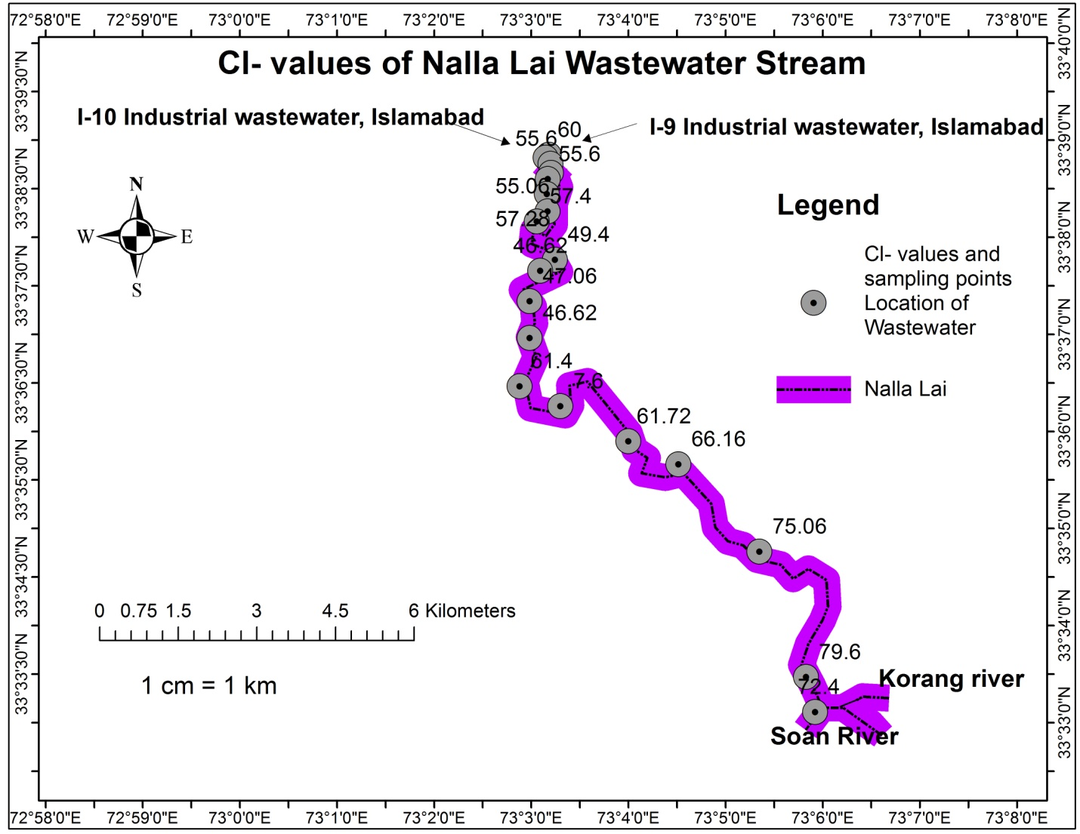

**Figure 9|** **Chloride** values of wastewater along the Nalla Lai stream

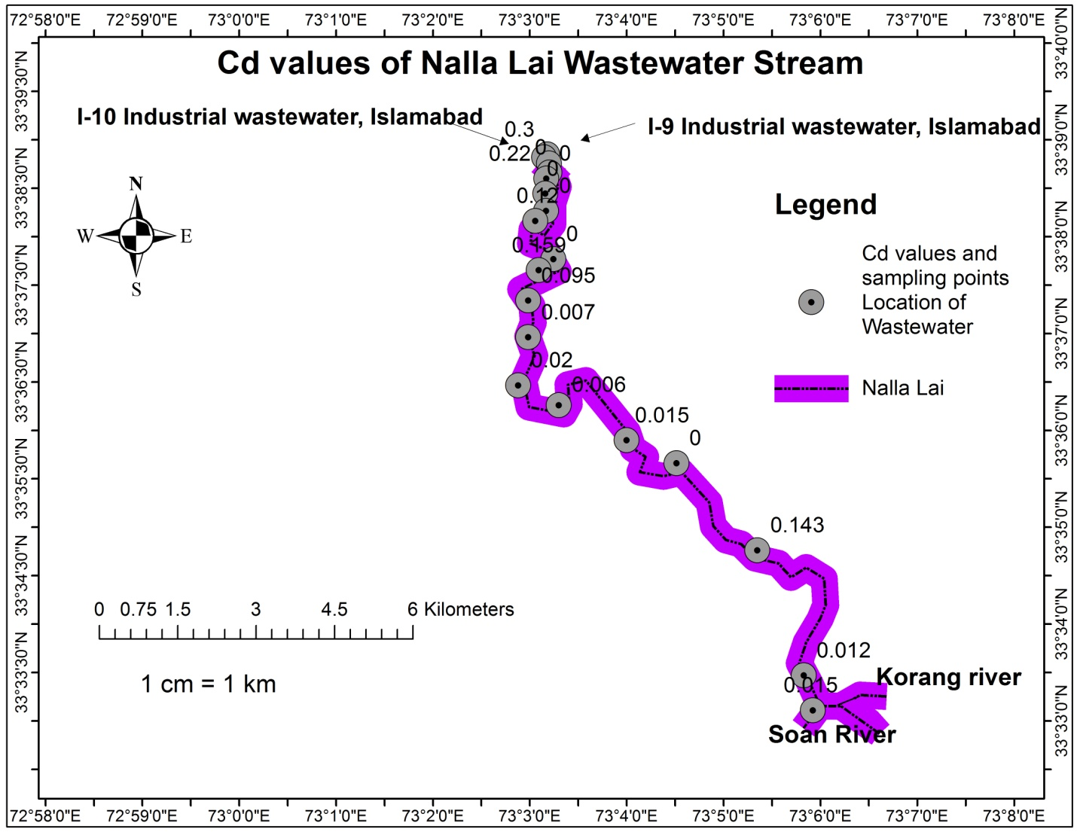

**Figure 10|** **Cadmium** values of wastewater along the Nalla Lai stream

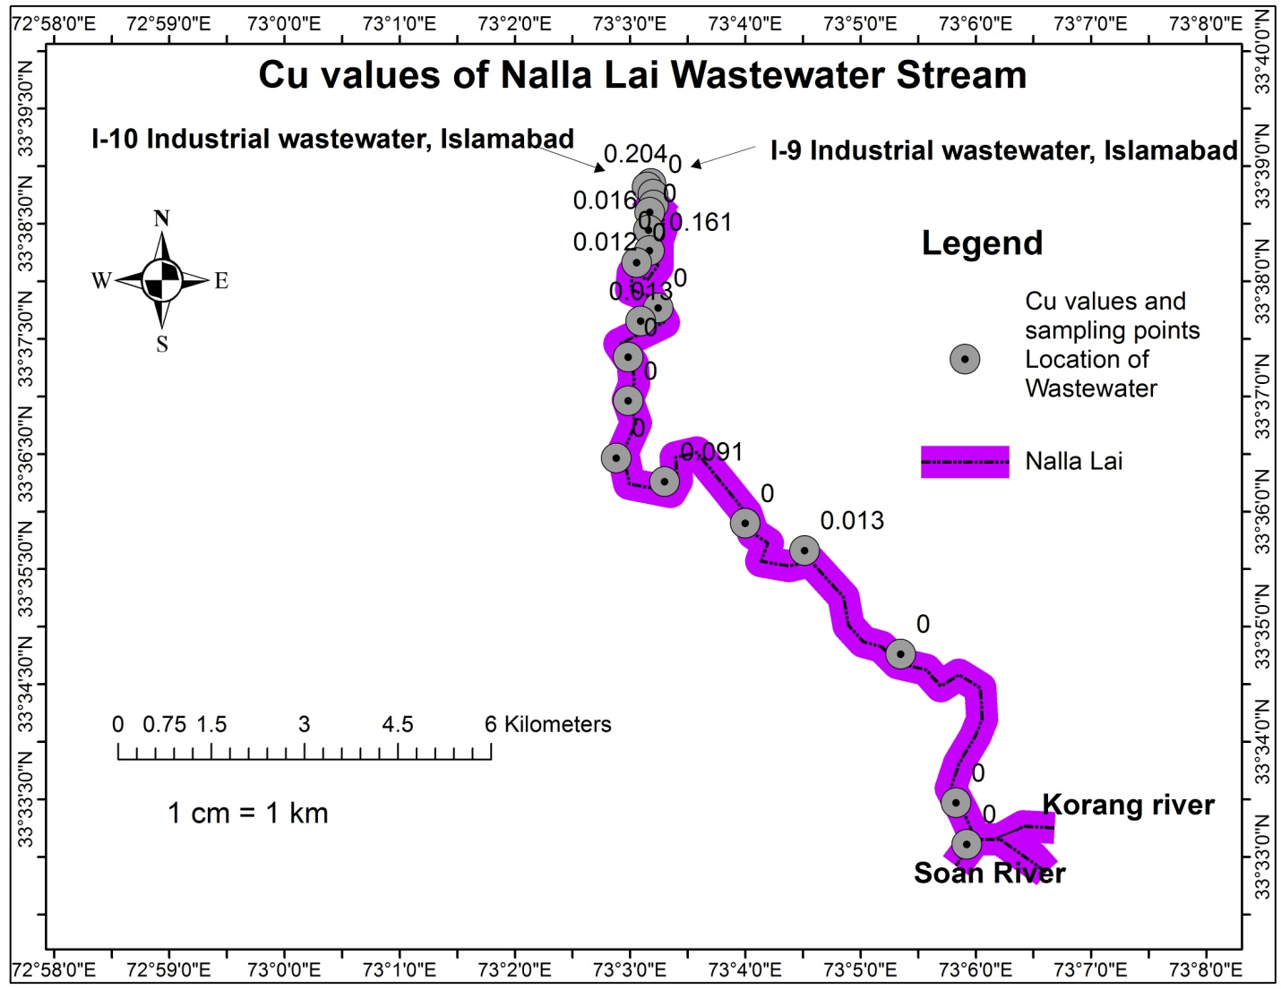

**Figure 11|** **Copper** values of wastewater along the Nalla Lai stream

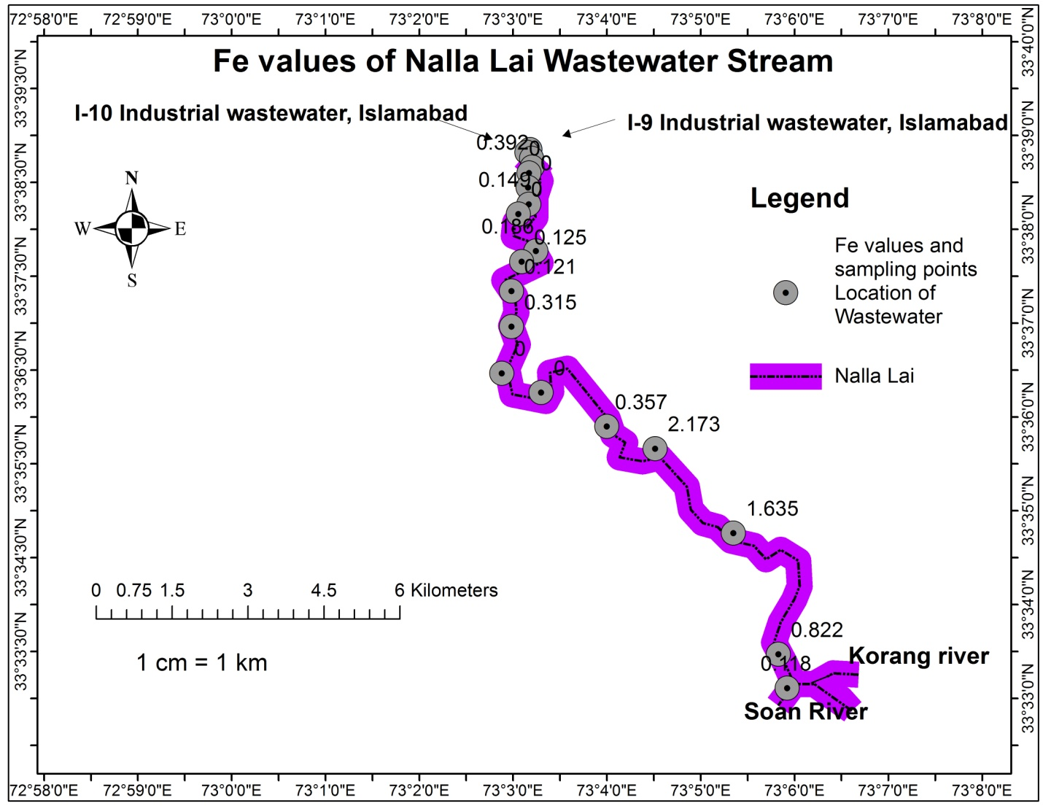

**Figure 12|** **Iron** values of wastewater along the Nalla Lai stream

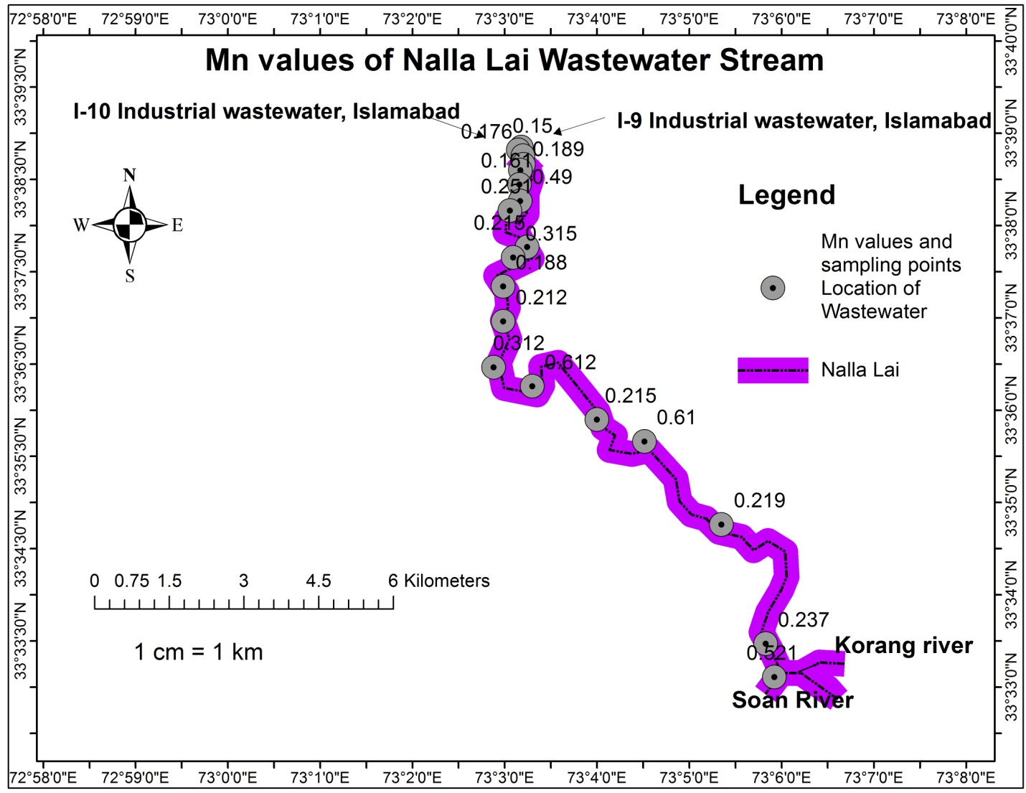

**Figure 13|** **Manganese** values of wastewater along the Nalla Lai stream

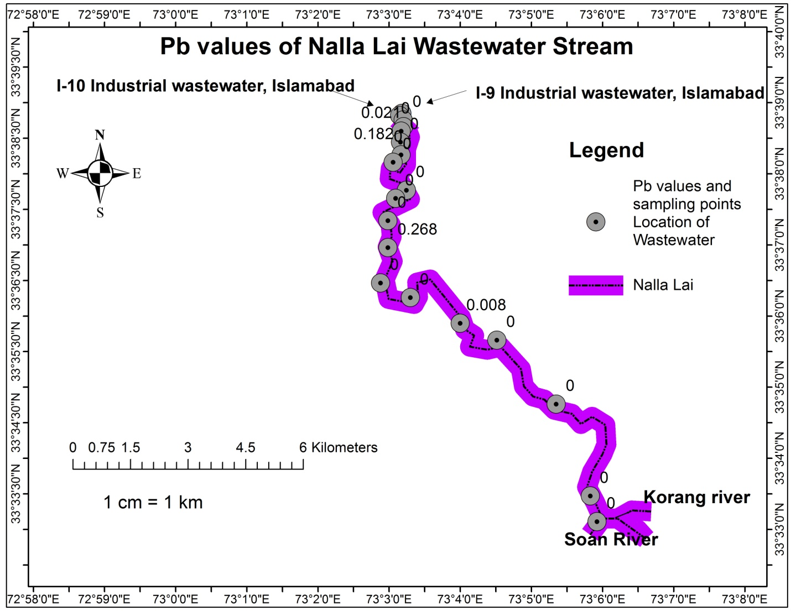

**Figure 14|** **Lead** values of wastewater along the Nalla Lai stream

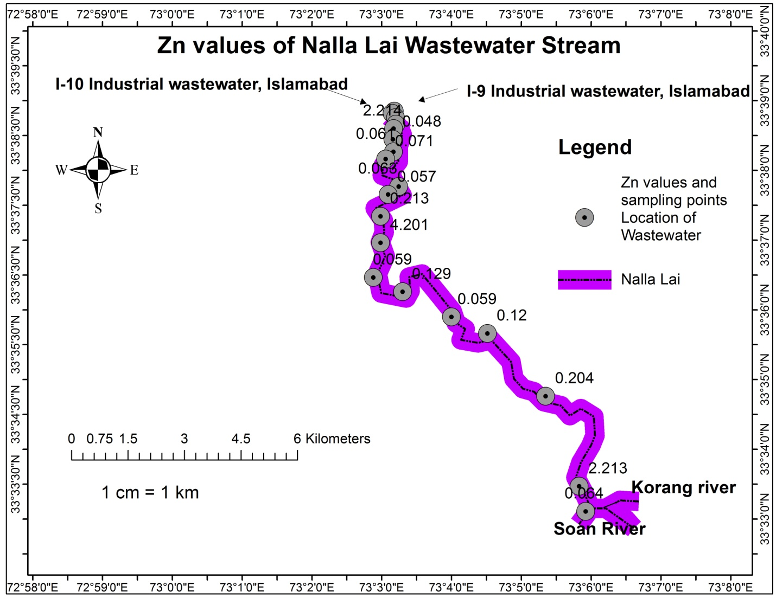

**Figure 15|** **Zinc** values of wastewater along the Nalla Lai stream

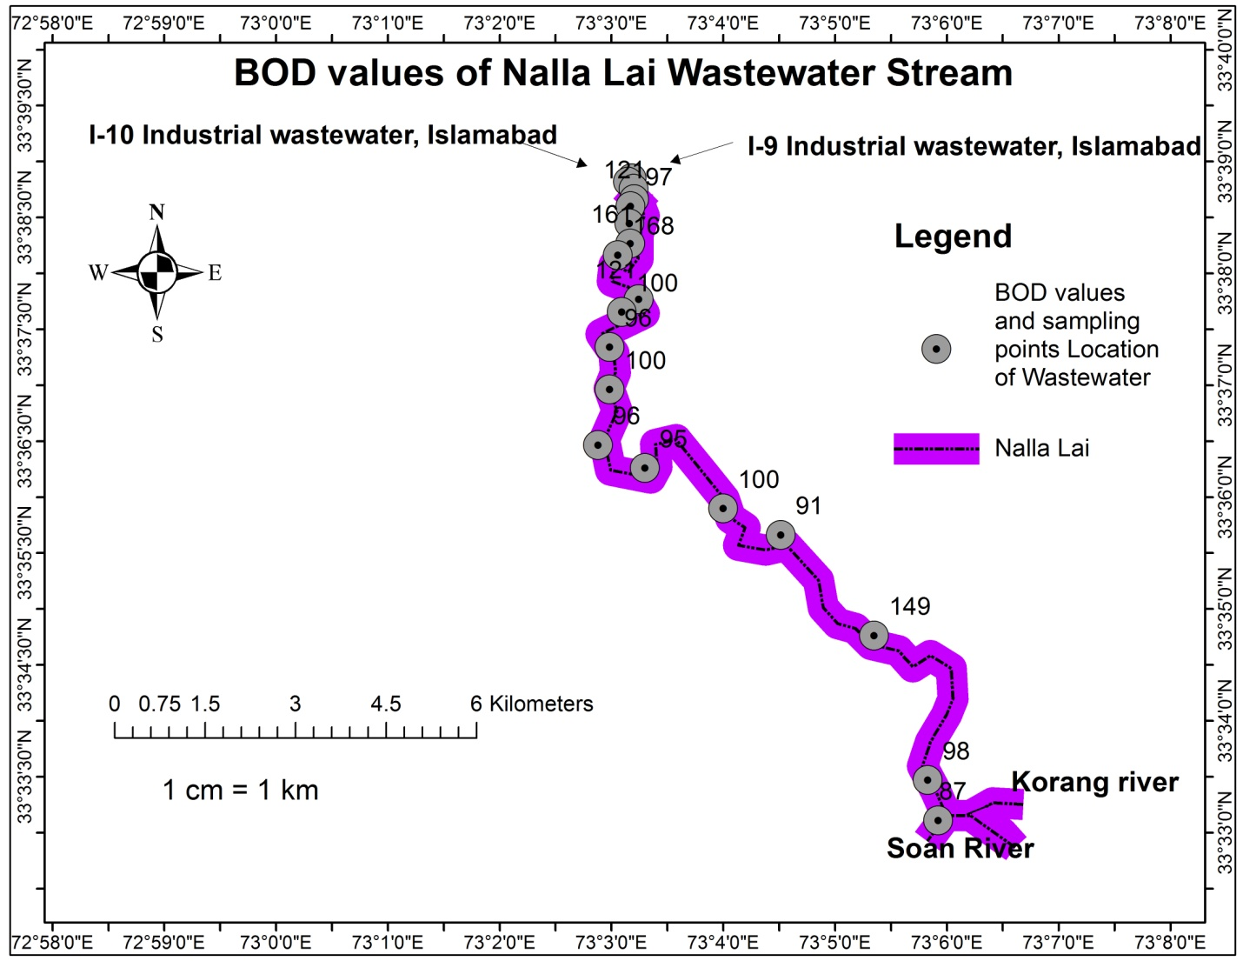

**Figure 16|** **Biological Oxygen Demand** values of wastewater along the Nalla Lai stream

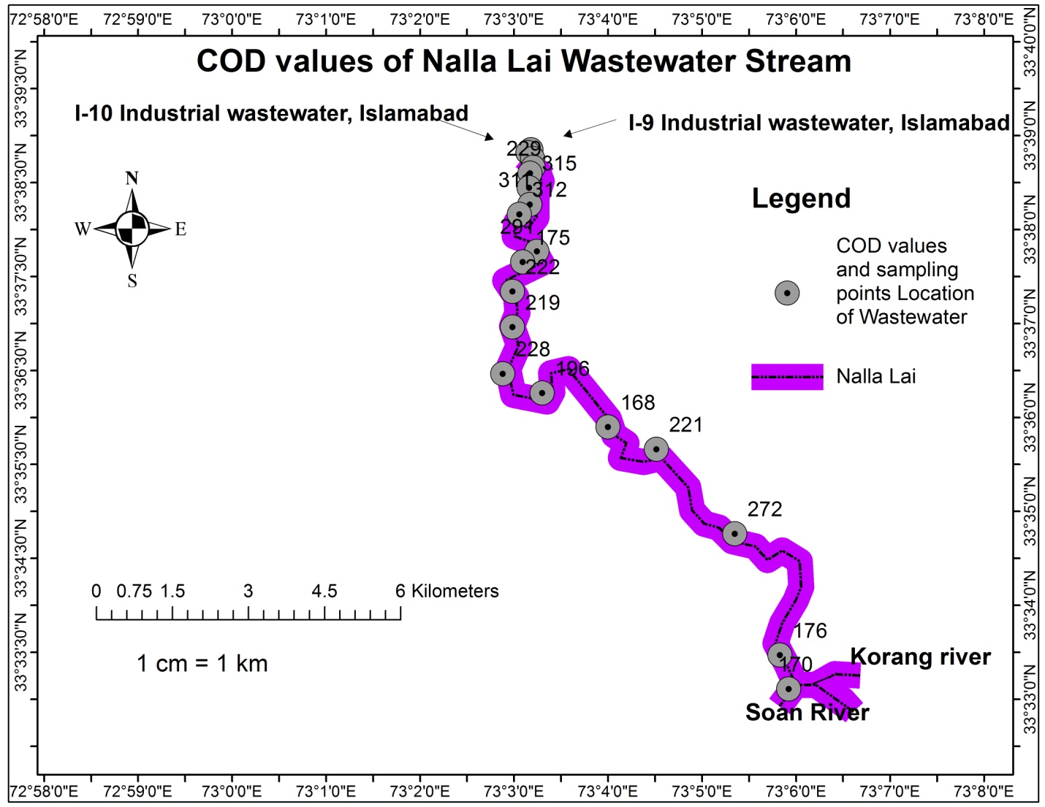

**Figure 17|** **Chemical Oxygen Demand** values of wastewater along the Nalla Lai stream